**DAILY ONLINE ACTIVITIES SUMMARY**

|  |  |  |  |  |  |  |  |  |
| --- | --- | --- | --- | --- | --- | --- | --- | --- |
| **Date:** | 05-06-2020 | | | | | **Name:** | D Richard Franklin | |
| **Sem & Sec** | Fourth sem section A | | | | | **USN:** | 4AL18CS020 | |
| **Online Test Summary** | | | | | | | | |
| **Subject** | | Data Communication | | | | | | |
| **Max. Marks** | | 30 | | **Score** | | | 28 | |
| **Certification Course Summary** | | | | | | | | |
| **Course** | 1. Java Programming | | | | | | | |
| **Certificate Provider** | | | greatlearning | | **Duration** | | | 3 hr |
| **Coding Challenges** | | | | | | | | |
| **Problem Statement:**  1: Program to rotate an array by N positions | | | | | | | | |
| **Status:** completed | | | | | | | | |
| **Uploaded the report in Github** | | | | | yes | | | |
| **If yes Repository name** | | | | | <https://github.com/alvas-education-foundation/Richard_Franklin> | | | |
| **Uploaded the report in slack** | | | | | yes | | | |

**Online Test Details:**

It was about the topic from module 5. The questions were all multiple choice questions which were optimal and easy to solve. The score that I got was 28/30.

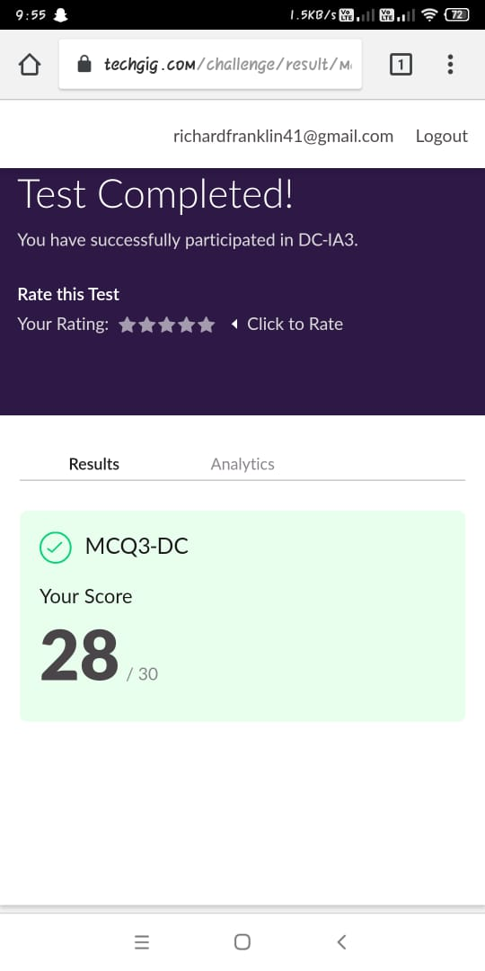

**Online Course Details:**

1. Name of course: **Java programming**

Certificate provider: greatlearning

The total course was about how one can code using this language and how this language is different from any other language; what specifically is peculiar in it. Basics of the language, different data structures and different functionalities of the language was taught.

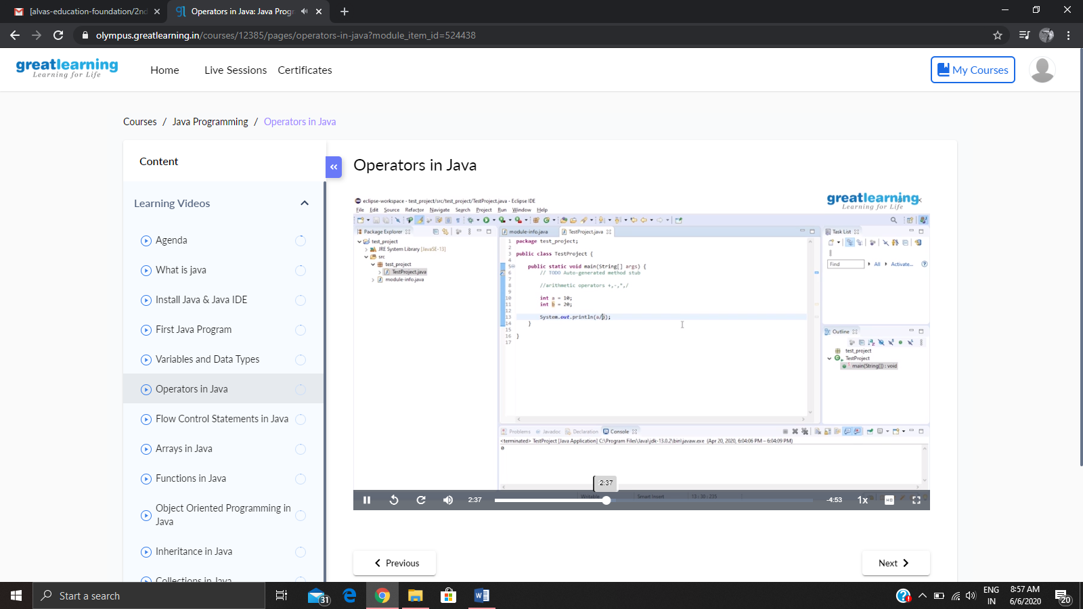

**Online coding:**

Problem 1: (using C) program to rotate an array by N positions

